Stop Smoking Interventions
General Practice Locally Enhanced Service Specification 2026

1. BACKGROUND AND RATIONALE
This Public Health Locally Enhanced Service (LES) Specification describes the provision of stop smoking interventions by General Practice surgeries located within the boundary of Plymouth City Council (PCC).
Smoking remains the single largest cause of preventable deaths and one of the largest causes of health inequalities in England (Wanless, 2004). There are still 7.3 million adult smokers and more than 200 people a day die from a smoking related illness that could have been prevented.
As well as dying prematurely, smokers also suffer many years in poor health. Many of the conditions caused by smoking are chronic illnesses, which can be debilitating for the sufferer and make it difficult to carry out day to day tasks and engage with society and the economy. Smokers proportionately are less likely to be in work.
There are an estimated 36,000 people who smoke in Plymouth. Smoking prevalence in adults is currently 16.6% in Plymouth, which is significantly higher than England (11.6%) and the South West region (11.2%) (APS 1 year range, 2023). However, smoking rates are higher in more deprived areas and are higher in males (17.4%) than females (15.7%). This pattern contributes to higher levels of smoking in routine and manual occupational groups (31.8%) in Plymouth. Furthermore, smoking prevalence also continues to be higher in those with mental health conditions.
The smoking attributable mortality rate per 100,000 people for Plymouth (2017-19) is 256, while the smoking attributable hospital admission rate per 100,000 people for Plymouth (2019/20) is 1,622, both of which are worse than the England averages.
People who smoke see their GP on average 35% more than people who do not smoke and are absent from work 2.7 days more per year compared to ex- and non-smokers. Smoking breaks also result in lost output for employers.
Tobacco is estimated to cost Plymouth more than £264 million per year. As part of this, tobacco-related medical treatment via hospital admissions and primary care, costs the NHS in Plymouth approximately £12.2 million per year (ASH Ready Reckoner, January 2025).
Tobacco-related ill health also leads to increased costs for the adult social care system. The total additional spending on social care for Plymouth amounts to an estimated £76.9 million per year.
Supporting a patient to stop smoking is one of the most cost-effective of all medical interventions. People who smoke are up to three times more likely to quit with pharmacotherapy and/ or a vape coupled with behavioural support from a Stop Smoking Advisor, compared to quitting without support. This Service Specification directly contributes to reducing the smoking prevalence in adults, which is a Health Improvement indicator of the Public Health Outcomes Framework.

2. AIMS AND OBJECTIVES OF THE SERVICE
The aim of this specification is to enable GP practices in Plymouth to provide a high quality, evidence-based and accessible tobacco dependence service to support the reduction of smoking prevalence.
This Public Health Locally Enhanced Service (PH LES) also supports the achievement of Health Improvement Smoking Cessation quitter targets as defined by the Office of the Director for Public Health (ODPH) within Plymouth City Council (PCC).
GP practice-based tobacco dependence services must:
- Support people to quit smoking, achieving quit rates between 35-70%.
- Offer the most effective evidence-based treatments available.
- Offer a choice of treatment options.
- Achieve high levels of client satisfaction.

3. SERVICE DESCRIPTION/PATHWAY
3.1 Service description
The service must follow the standard treatment programme outlined in the NCSCT guidance. The standard treatment programme consists of a pre-quit assessment (one or two weeks prior to quit date) and two weekly sessions until four weeks after the quit date, alongside the prescribing of pharmacotherapy and/ or the provision of a vape. This is summarised in the local Smoking Cessation Guidelines for General Practice (Appendix 3).
Staff must use the Heaviness of Smoking Index (HSI) or Fagerstrom test alongside a CO reading to assess nicotine dependence and use this to inform pharmacotherapy/ vape recommendations. Provision of pharmacotherapy must be in line with training provided and guidance from the British National Formulary/South West Devon Formulary and Referral (SWDFR).
Face-to-face delivery of stop smoking support is evidenced to be the most effective model of delivery and is therefore preferred within this service. However, a combination of face-to-face and virtual support (including phone calls, video calls, email or SMS), or entirely virtual support, can be given depending on the client’s preferences, as long as provision continues to follow the standard treatment programme. When entirely virtual delivery is necessary, CO monitoring may not be possible. Useful guidance on virtual delivery can be found on the NCSCT website.
Delivery within a group setting is permitted and encouraged where appropriate, providing that the standard treatment programme structure is still followed, and individuals can access personalised and private advice when they need it. It is advisable for the practitioner to have attended Group Facilitation training.
Patients should be accurately informed about Nicotine Replacement Therapy (NRT) and other pharmacotherapies as recommended by the SWDFR, as well as being provided with information and an offer of vapes. Pharmacotherapies should be prescribed as appropriate, ensuring that the patient is offered a choice of where to receive the help they need to quit smoking. Supporting patients to quit with pharmacotherapy and/ or vapes and behavioural support is the most effective and cost-effective way of helping patients to quit, as recommended by NICE. However, there will be some instances where this is not always acceptable to the patient. Follow up will be required and a monitoring form raised in all circumstances.
The Practitioner will CO validate all face to face quit attempts using a hand-held carbon monoxide monitor, such as a Smokerlyzer®.
Unsuccessful quitters may be seen again under this PH LES but repeating/re-starting the service should be in line with SWDFR recommendations.
Interventions should be based on the current evidence and follow relevant NICE guidance.
Pharmacotherapy: Medication, Nicotine Replacement Therapy (NRT) and Vapes
When prescribing and/or recommending pharmacotherapy – currently nicotine replacement therapy (NRT), varenicline, bupropion (Zyban) and Cytisine, or e-cigarettes/vapes – this must be done in combination with intensive behavioural support, as outlined in the standard treatment programme. Quit attempts made using pharmacotherapy or vapes alone without behavioural support cannot be claimed for as part of this service.
Varenicline, Cytisine, e-cigarettes/vapes or combination NRT offer smokers the best chance of quitting and, unless contraindicated, should be available as first-line treatments to all clients. Pharmacotherapy must only be provided for a maximum of 12 weeks for each quit attempt, although may be extended in exceptional circumstances at the advisor’s discretion if they feel it is important to prevent relapse. Each further attempt to quit should be treated as a new attempt. Patients may wish to purchase their own NRT after the 12-week period if they feel they still require it. Patients should be assessed for suitability of recommended smoking cessation medications/ vapes before prescribing or providing.
The service can offer access to e-cigarettes/vapes as part of its stop smoking offer in line with NICE Guidance NG209. These will be delivered directly to the patient’s address from our registered supplier on the instruction of the Practice.
The Stop Smoking evidence base is continuously evolving and advisors must keep up to date with published guidance. When providing stop smoking support or advice on nicotine-containing e-cigarettes/vapes, the provider must:
- Give clear, consistent and up-to-date information about nicotine-containing e-cigarettes to adults who are interested in using them to stop smoking. See:
  - The NSCST e-cigarette guide: ‘Vaping: a guide for healthcare professionals’.
  - Information from the Office for Health Improvement and Disparities (OHID) on e-cigarettes and vaping.
  - Plymouth City Council/ Specialist Stop Smoking Service briefing on Vaping.
- Advise adults on how to use nicotine-containing e-cigarettes, which includes explaining:
  - E-cigarettes are not licenced medicines, but they are regulated by the Tobacco and Related Products Regulations (2016)
  - There is not enough evidence to know whether there are long-term harms from e-cigarette use.
  - Use of e-cigarettes is likely to be substantially less harmful than smoking
  - Any smoking of tobacco is harmful, so people using e-cigarettes should stop smoking tobacco completely.
- Discuss:
  - How long the person intends to use nicotine-containing e-cigarettes for.
  - The importance of using them for long enough to prevent a return to smoking.
  - How to stop using them when they are ready to do so.
- Ask adults using nicotine-containing e-cigarettes about any side effects or safety concerns that they may experience and report these to the MHRA Yellow Care Scheme.

Further attempts to quit after 28 days
It is recognised that some clients require more than 28 days to quit successfully. If a client has not quit at four weeks, the stop smoking advisor should assess the client’s motivation again and use their professional judgement over whether to continue to provide behavioural support and pharmacotherapy/ vapes. In such cases, the original data set should be submitted as ‘not quit’ and a new entry with a new quit date initiated. This procedure should only be used in cases where the stop smoking advisor believes the client is able to quit in the next six weeks. It must not be used where clients appear to be ‘cutting down to quit’.
Clients who have already been supported twice by Level 2 intermediate advisors and failed to quit should be offered a referral to specialist stop smoking advisors in the Livewell Southwest Wellbeing Team. The Practice may continue to support them if that is what the patient wishes, however, no more than four quit attempts for the same patient may supported in any one financial year.

3.2 Eligible population
The specification applies to [GP surgeries/Community Pharmacies] located within Plymouth City Council Boundary. The specification covers residents in Plymouth City Council Local Authority Area.
Where appropriate, inter-practice referral arrangements can be made to deliver this specification.

3.3. Referral pathways
The availability of support to stop smoking should be prominently advertised within the setting.
The provider will have multiple touch points with people who smoke tobacco. Evidence shows that brief opportunistic clinician advice can increase quit attempt rates by 40%. Establishing practice-wide pathways that integrate brief advice and opt-out referrals to in-house services is an effective strategy to increase access to tobacco dependence treatment.
All appropriate staff should regularly refer people who smoke tobacco and are ready to quit to either their in-house stop smoking practitioner or to the specialist service, as per the Smoking Cessation Guidelines (Appendix 3). In particular, people who smoke tobacco and who are receiving an NHS Health Check should be offered referral to the in-house stop smoking service, preferably on an opt-out basis.
Level 3 stop smoking advisors can provide specialist support and access to free, direct supply NRT for those who receive free prescriptions and and/ or free vapes for all patients. Although this is a universal service, they are trained to help those who find it very hard to quit, e.g. the very dependent or those who relapse frequently. Therefore, patients who may require a higher level of support may benefit from being referred directly to Plymouth’s Level 3 specialist stop smoking advisors in the Livewell Southwest Wellbeing Team (Appendix 1).
The Practitioner will refer to the Livewell Southwest Wellbeing Team anyone who they feel would benefit from more intensive specialist support than can be offered in General Practice. This may include people who are aged under 18, pregnant women, adolescents, those with specific diseases (e.g. Chronic Obstructive Pulmonary Disease or Cardiovascular Disease), smokers with mental health problems or learning difficulties, and people who are heavily dependent on nicotine.

3.4 Inclusion, exclusion and prioritisation criteria
This specification covers the provision of support to people who smoke tobacco (aged 18 and over) and are registered with GP practices within Plymouth City Council’s geographical area. Torbay and Devon residents may be included if the quit attempt, from start to finish, is provided by a practice which falls in the Plymouth City Council geographical footprint.
Those under 18 should be referred onto the specialist service for support (see Appendix 1).
Pregnant women who smoke tobacco may be supported by Level 2 community stop smoking services if that is their preference. The first line treatment pathway for this population is the treating tobacco dependence service provided directly by Maternity Teams in Secondary Care.
Smokeless tobacco: Supporting people to quit smokeless tobacco is not covered by this contract, e.g. chewing tobacco.
Supporting attempts to stop vaping: the service is not commissioned to support users of unlicensed nicotine containing products (such as vapes) who do not smoke tobacco, to stop their use of such products.

3.5 Location and times of service
The service will be delivered at any location identified by the provider that meets appropriate clinical governance standards required to deliver the specification.
Core delivery hours are expected to be aligned with the providers normal service delivery hours.

3.6 Exiting the service
Wherever possible the provider will work to facilitate a planned exit from the service. Where appropriate and necessary the provider will ensure referral onto other services.

3.7 Interdependencies
Providers should be aware of the importance of effective partnership and system to improve the quality of care offered to residents.
This PH LES will act as part of a coordinated city-wide Stop Smoking Service and is therefore interdependent with the core smoking cessation specialist service located within Livewell Southwest Wellbeing Team. The specialist service will:
- Provide reasonably accessible training to act under this PH LES.
- Provide each Practice providing this PH LES with a Smokerlyser free of charge for use in providing this service.
- Be available (in the form of the Livewell Southwest Wellbeing Team, see Appendix 1) to provide expert advice and support to Practitioners when required.
- Send quarterly reminders to submit relevant monitoring forms to Livewell Southwest Wellbeing Team.
- Provide feedback to the General Practice in relation to smoking cessation activity and the number of CO verified four week quitters.

4. SERVICE STANDARDS AND REQUIREMENTS
The providers should identify a named person to oversee the delivery of the specification and maintain an awareness of current relevant clinical guidance and its application.

4.1 Applicable local and/or national standards
Providers must ensure that provision of this specification meets the following standards of service quality and clinical governance:
- NICE guidance: https://pathways.nice.org.uk/pathways/smoking
- The Russell Standard: www.ncsct.co.uk/publication_The-Russell-Standard.php
- The NCSCT Standard Treatment Programme: Standard treatment programme
- NCSCT Local Stop Smoking Services and Support: Commissioning, Delivery and Monitoring Guidance: Commissioning-delivery-and-monitoring-guidance.pdf
- South and West Devon Formulary and Referral
- Practitioner Monitoring form (Appendix 2)
- Smoking Cessation Guidelines (Appendix 3).

  - Monitoring and audit
Practices should collect monitoring data (Appendix 2) for each patient supported on each attempt and ensure that quality meets the standards set out in the Russell Standard (clinical) and the definitions as set out in the 2024 NCSCT Commissioning and Delivery Guidance. A successful quitter is defined by the guidance as “a treated smoker who reports not smoking for at least days 15–28 of a quit attempt (-3 or +14 days).” For CO verified quits, the CO reading must be assessed 28 days from their quit date (-3 or +14 days) and be less than 10ppm.
Completed monitoring forms should be sent to the Livewell Southwest Wellbeing Team (Appendix 1) within two weeks of the final consultation for that patient, or as soon as the intervention is completed.
The full data set should be submitted for every patient, even those who are unsuccessful in their quit attempt.
Consenting clients may be asked to complete a customer satisfaction survey, as coordinated by the Livewell Southwest Wellbeing Team.
The patient must be informed that their anonymised data will be shared with Plymouth City Council and NHS England for national reporting, and verbal consent must be obtained.
Attempt CO monitoring at the four-week quit review session (recommended in a minimum of 85% of cases who receive face to face support). CO monitoring is an important data quality marker and motivational tool.
Ensure that the four-week quit review session occurs between 25 and 42 days from the quit date that was set.
Make a minimum of three attempts to contact clients whose smoking status is ‘unknown’ using different methods of contact and at different times of the day. If the four-week outcome for a patient is unknown after three attempts to contact, they should be recoded as “lost to follow up.”
Review meetings will be arranged by mutual agreement between the provider and the commissioner as required.
Any significant incidents arising from this PH LES should be reported to PCC as per PCC guidelines.

Locally agreed outcomes and quality requirements
Outcome | Measure | Annual Target | Evidence Source | Reporting mechanism
Smoking Prevalence – Adult (over 18) | Rate of 4-week quitters (%) | 35% | Monitoring Forms sent to  Livewell Southwest  Wellbeing Team  (Appendix 1) | Quarterly Report

4.3 Clinical governance and quality assurance
Providers must have systems in place for:
- Reporting and investigating incidents and near misses.
- Learning from adverse events and implementing improvements.
- Escalating safeguarding concerns appropriately.
- Obtaining and recording informed consent prior to delivering an intervention.

4.4 Staff competencies, training and accreditation requirements
Staff delivering the service must be suitably qualified and be able to provide evidence of their required experience and qualifications if requested by the commissioners.
Advisors do not need to be qualified healthcare professionals. The Level 2 Stop Smoking Advisor training requirements are detailed below.
Essential:
- At least one person per Practice will undertake a two-day workshop (Community Practitioner Training) delivered by the Livewell Southwest Wellbeing Team before providing services under this PH LES. The training will be run to NCSCT required training standards.
- Anyone who has attended training from other Stop Smoking Services or from the Maudsley Clinic will be able to practice providing they have continued to update their knowledge and skills through annual updates, at the discretion of the Livewell Southwest Wellbeing Team.
- NCSCT e-learning training module Vaping a Guide for Healthcare Professionals.
- Practitioners are expected to undertake at least one ongoing training session annually to ensure they are kept up to date with new evidence and research.
- A Practice’s Practice Manager, GPs and Stop Smoking Practitioner(s), as appropriate, should attend a briefing from the Livewell Southwest Wellbeing Team to understand the Smoking Cessation Guidelines (Appendix 3) and this PH LES.
Recommended:
- Completion of Making Every Contact Count (MECC) e-learning at www.e-lfh.org.uk/programmes/making-every-contact-count
- Completion of the online NCSCT very brief advice training (available from www.ncsct.co.uk/publication_very-brief-advice.php) by other staff within the Practice to encourage screening for tobacco use, conversations about tobacco dependence and referrals into Plymouth’s Specialist Stop Smoking Service.
- On completion of training, advisors will be added to the register of Level 2 Stop Smoking Advisors in Plymouth, held by the Livewell Southwest Wellbeing Team and shared with Plymouth City Council.
Continuous Advisor Support:
- The advice of the Livewell Southwest Wellbeing Team may be sought by the Practice at any time.
- Additional training is available from the Livewell Southwest Wellbeing Team, including training on the use of vapes and very brief advice training.
- The NCSCT website also has a range of additional online training that can be accessed for free, including modules on pregnancy, mental health and vaping.

4.5 Premise and equipment standards
Providers must comply with national infection prevention and control (IPC) standards including use of sterile equipment and aseptic technique (if applicable), appropriate disposal of clinical waste and regular audit of IPC practices
Consultations should take place with a registered advisor in a room or area that can provide clients with a confidential service or over the telephone if the patient prefers.
The General Practice is responsible for ensuring that professional indemnity insurance arrangements are in place for the operation of the public health service.
All equipment used must be used in line with the manufacturers’ guidance and protocols for safe and effective use.
Carbon monoxide (CO) monitors will be issued and maintained by the Livewell Southwest Wellbeing Team.
The Practice must supply and use the correct disposable mouthpieces for the CO monitor they have been supplied.

5. PAYMENT AND PRICING
5.1 Tariff type
Payment will be made in arrears by PCC directly to the provider on a pay by activity basis, following a review of the quarterly activity submissions from the provider.

5.2 Payment structure
Part A (below) should be claimed for all clients who attend the pre-quit assessment appointment and set a quit date (Standard Treatment Programme).
One element from Part B (below) should be reported/claimed for alongside Part A based on outcome, as detailed in the table below.
PART | Stop Smoking | Tariff
A | Quit date set  - Attends pre-quit assessment appointment and sets a quit date | £15.00 per ‘quit date set’*
B  OUTCOME | Not Quit  - Patient attends full treatment programme but is not quit at four weeks | £20.00
B  OUTCOME | Quit (Unverified)  - Patient attends full treatment programme and self reports as quit at four week follow up, without CO verification | £40.00
B  OUTCOME | Quit (Verified)  - Patient attends full treatment programme and is quit at four week follow up, which is verified via CO monitoring in person | £45.00
B  OUTCOME | Disengagement (week 3+)  - Patient has disengaged (opted out or lost to follow up) and has not completed the full treatment programme, but has attended at least 2 appointments | £15.00
B  OUTCOME | Quit Discontinued  - Patient attended the first appointment and set a quit date, but subsequently disengaged (opted out or lost to follow up) without a further appointment | No additional payment
*the same patient may set more than just one quit date on a single journey to become smoke-free, as long as the advisor feels confident they are ready to make another committed attempt each ‘quit date set’ and pre-quit assessment should be counted as an individual episode with the accompanying outcome. There can be a maximum of four quit dates set for any one client per year.
No additional remuneration is available for Practitioners’ time spent training etc.
No additional remuneration is available for other General Practice staff members’ time in relation to this PH LES.

At times the commissioners may query the activity submissions made by providers. Relevant payments to the provider will be made following resolution of these queries.
Quarterly reporting deadlines ‘Schedule of Deadlines & Payments’ will be sent to practices by LWSW each financial year. Deadlines are based around submission dates set for the Stop Smoking Services Collection - NHS England Digital.
There will be no further opportunity to claim for activity reported out of each financial year after the Q4 public health reporting deadline has closed.

6. CONTRACT MANAGEMENT
6.1 Reporting frequency and format
The provider will submit the PCC Quarterly Public Health Services Activity Report within 24 days of the end of the quarter.
The quarterly submission schedule is shown below:
Quarter | 1 |  | 2 | 3 |  | 4
Dates covered: | 1 Apr – 30 June |  | 1 July – 30 Sept | 1 Oct – 31 Dec |  | 1 Jan – 31 Mar
Submission due by: | 24 July |  | 24 Oct | 24 Jan |  | 24 Apr

Submitted data will be used to calculate payments due.

6.3 Contract review
Review meetings will be arranged by mutual agreement between the provider and the commissioner as required.

Appendix 1 Plymouth NHS Stop Smoking Service

Contact details:
Livewell Southwest Wellbeing Team
Mount Gould Admin Block
200 Mount Gould Road
Plymouth
PL4 7QD
Telephone 01752 437177
Email: oneyou.plymouth@nhs.net
Website www.oneyouplymouth.co.uk

The Livewell Southwest Wellbeing Team offers a wide range of support to Community Practitioners/patients including:

Provision of specialist clinic and groups across the city

Provision of specialist support for pregnant women & their families

Provision of specialist services in Wellbeing hubs across the city

Provision of NCSCT standard training - workshop plus a whole range of training to support people to quit with differing needs.

Provision of an annual conference to update skills and raise awareness of smoking related issues

Provisions of in-practice brief intervention training, plus additional seminars

Provision of CO monitors, materials and resources

Data collection and feedback to practices

Practice visits to support practitioners

Telephone support to practitioners

Appendix 2Community Practitioner Monitoring form 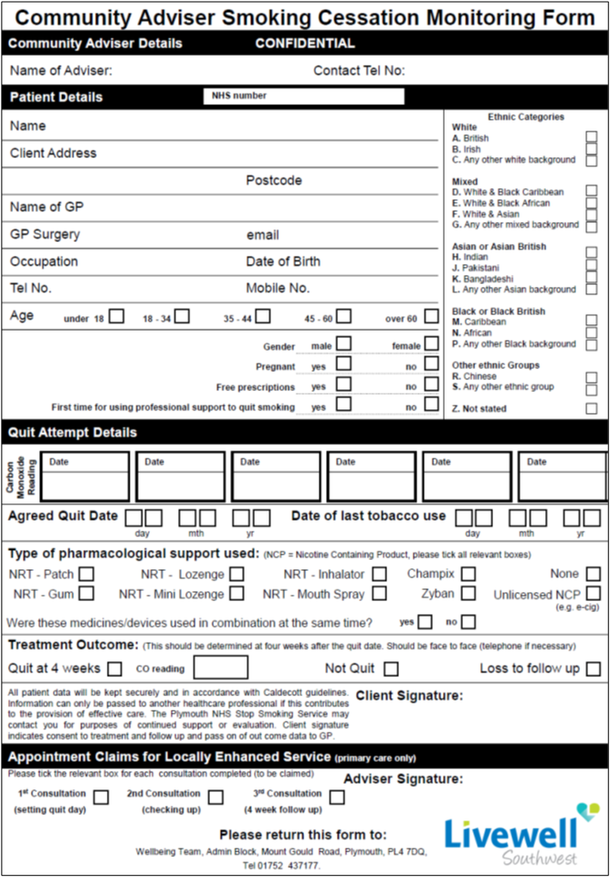

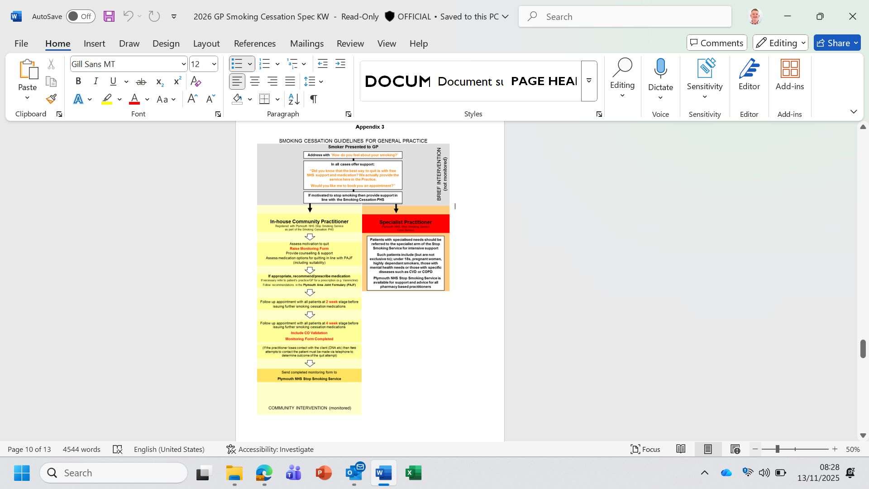

Appendix 4 Glossary of terms

CO-verified quit
A treated smoker who reports not smoking for at least days 15–28 of a quit attempt and whose Carbon monoxide (CO) reading is assessed 28 days from their quit date (-3 or +14 days) and is less than 10 ppm. The -3 or +14 day rule allows for cases where it is impossible to carry out a face-to-face follow-up at the normal four-week point (although in most cases it is expected that follow-up will be carried out at four weeks from the quit date). This means that follow-up must occur 25 to 42 days from the quit date (Russell Standard).

CO verification should be conducted face to face and carried out in at least 85% of self-reported four-week quitters who receive face to face support.

Commissioner
Plymouth City Council.

LoR
Letter of Recommendation (for Varenicline).

Lost to follow-up (LTFU)
A treated smoker who cannot be contacted face to face, via telephone, email, letter or text following three attempts to contact them at different times of day, at four weeks from their quit date (or within 25 to 42 days of the quit date). The four-week outcome for this client is unknown and should therefore be recorded as LTFU on the monitoring form.

PH LES Public Health Locally Enhanced Service.

Practitioner
Stop Smoking Practitioner, employed by the Provider Lead named above.

Stop smoking service provider
A stop smoking service provider is defined as a locally managed and coordinated service commissioned to provide accessible, evidence-based and cost-effective clinical services to support smokers who want to stop. Service delivery should be in accordance with the quality principles for clinical and financial management contained within this guidance.

Non-treated smoker
A smoker who receives no support or is given very brief advice and/or supplied with leaflets, helpline cards or pharmacotherapy only, and who does not set a quit date or consent to treatment. Examples may include smokers seen at health fairs or community events, during a GP consultation or during a hospital stay where a quit date is not set and a quit attempt is not made.

Provider Lead
General Practice providing the service to patients.

Quit date
The date a smoker plans to stop smoking completely with support from a stop smoking practitioner as part of an assisted quit attempt.

Renewed quit attempts
A quit attempt that takes place immediately following the end of one treatment episode. A new treatment episode should be commenced in the database / service records.

Routine and manual smoker
A smoker whose self-reported occupational grouping is of a routine and manual (R/M) worker as defined by the National Statistics Socio-Economic Classification.137

Unverified Quit
A treated smoker who reports not smoking for at least days 15–28 of a quit attempt and is followed up 28 days from their quit date (-3 or +14 days) but who has not verified this with CO reading. The -3 or +14 day rule allows for cases where it is impossible to carry out a face-to-face follow-up at the normal four-week point (although in most cases it is expected that follow-up will be carried out at four weeks from the quit date). This means that follow-up must occur 25 to 42 days from the quit date (Russell Standard).

Smoked product
Any product that contains tobacco and produces smoke is a smoked product, including cigarettes (hand-rolled or tailor-made), cigars and pipes (including waterpipes). Waterpipes include shisha, hookah, narghile and hubble-bubble pipes.

Smoker
A person who smokes a smoked product. In adulthood this is defined in terms of daily use, whereas in adolescence (i.e. for those aged 16 or under) it is defined in terms of weekly use.

Smoking cessation
In clinical terminology this is used to denote activities relating to supporting smokers to stop.

Specialist Service
Livewell South West Wellbeing Team

Spontaneous quitters
Smokers who have already stopped smoking when they first come to the attention of the service can only be counted as having been ‘treated’ and included in the national data return if they had quit 48 hours or less before attending the first session of a structured multi-session treatment plan. Where this is the case, their spontaneous quit date should be recorded as their actual quit date. Examples of such quitters include clients who experience unplanned admission to hospital and stop smoking before receiving support, those people who have started using nicotine vapourisers (as an
alternative to smoking) and have not smoked for up to 48 hours, or pregnant smokers who have already stopped smoking before approaching their local stop smoking service provider. Whilst it is recognised that it is desirable to offer support to as many people who smoke as possible, local commissioners will need to balance the needs of their smoking population against available service resources. People who smoke who have already stopped smoking for more than 48 hours before attending a service should not be included in the national data submission but may be counted as having been ‘treated’ for local accounting purposes (e.g. to justify resources used or analyse performance). It is recommended that this is only recorded if they have quit within 14 days prior to coming to the attention of the service and have attended the first session of a structured multi-session treatment plan within 14 days of their spontaneous quit date (which should be recorded as their quit date).

Stop smoking
Preferred term to denote patient-facing communications relating to smoking cessation activity.

Stop smoking practitioner
An individual who has NCSCT certification and is employed by a service which is, either directly or indirectly, commissioned to provide stop smoking support.

Time between treatment episodes
(see Treatment episode, below)
When a client has not managed to stop smoking, there is no definitive period of time required between the end of a treatment episode and the start of another. The stop smoking practitioner should use discretion and professional judgement when considering whether a client is ready to receive support to immediately attempt to stop again. If this is the case, the client must start a new treatment episode, i.e. attend one session of a structured, multi-session intervention, consent to treatment and set a quit date with a stop smoking practitioner in order to be counted as a new data entry on the quarterly return.

Treated smoker
A smoker who has received at least one session of a structured, multi-session intervention (delivered by a stop smoking practitioner) on or prior to the quit date, who consents to treatment and sets a quit date with a stop smoking practitioner. Smokers who attend a first session but do not consent to treatment or set a quit date should not be counted.

Treatment episode
At the point of attending one session of a structured, multi-session intervention, consenting to treatment and setting a quit date with a stop smoking practitioner, a client becomes a treated smoker and the treatment episode begins. The treatment episode ends when a client has been completely abstinent for at least the two weeks prior to the four-week follow-up or is lost to follow-up at the four-week point, or when a four-week follow-up reveals that a client has lapsed during the two weeks immediately prior to the follow-up and is therefore recorded as a non-quitter. Good practice dictates that if the client wishes to continue treatment after a lapse, treatment should be continued if it seems appropriate, but the client will not count as a four-week quitter for the purposes of that treatment episode.

